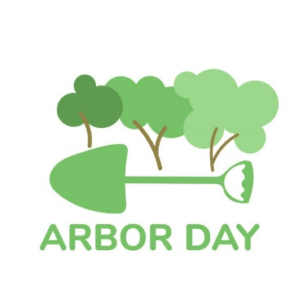

PENNINGTON ARBOR DAY CELEBRATION
APRIL 28, 2023

For 35 years, Pennington Borough has been recognized as a Tree City by the Arbor Day Foundation. Celebrating Arbor Day with a tree planting and proclamation is one of the four steps needed to receive this recognition.

This year, on April 28, Toll Gate Grammar School first graders will gather once again with their teachers and members of Pennington’s Shade Tree Committee to plant a Kwanzan Cherry tree, and to learn about the importance of tree care. The event will take place at 11:45 am, in front of Toll Gate. Families are welcome to attend.

The Borough will also issue a proclamation to commemorate Arbor Day in which Mayor James Davy will encourage everyone to support efforts to protect trees and woodlands, and to support our urban forestry program.

The Pennington Shade Tree Committee consists of seven volunteers, along with members of the Public Works Department and a council liaison. The trained committee is responsible for maintaining the health and diversity of the Borough’s urban forest and street trees. Committee members include Suzen Witcher, Gabriel Rosko, Kate Fullerton, Michael Rheinhardt, Cécile Vidican, Jaye Berman and Nadine Stern.

